Arduino Lesson 15
LED Digital Display
- Intro
Digital display is a semiconductor light emitting device, and its basic unit is a light-emitting diode. According to the light emitting diode unit connection mode,there are common anode and common cathode digital displays.
Common anode refers to put all the anode of the light emitting diodes together to form a common anode(COM)display.COM stay connect to +5v in applications. When the cathode level is low, the relevant section will be lightened. Lights go off when the cathode level is high. Each segment compose of light emitting diode, like light-emitting diodes (leds), also need to connect current-limiting resistor, otherwise will burn the light emitting diode.
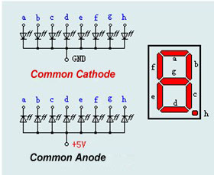
We use common cathode 8-segament display (with decimal dot) in this experiment. (Please search online for tutorial if you bought the common anode display and still don’t know how to connect it after you read the above introduction.)

The COM cathode should connect to the ground pin(GND). When the anode level is low, the relevant section will stay turn-off. Lights on when the anode level is high.
- Parts Required
8-segment led display x 1
220ΩResistors x 8
Breadboard x 1
Jumper wires x 1 Bundle

- Connect-it-up
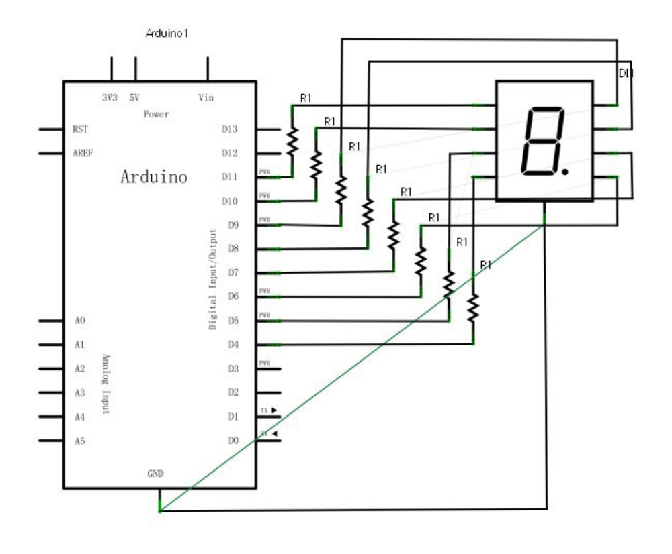
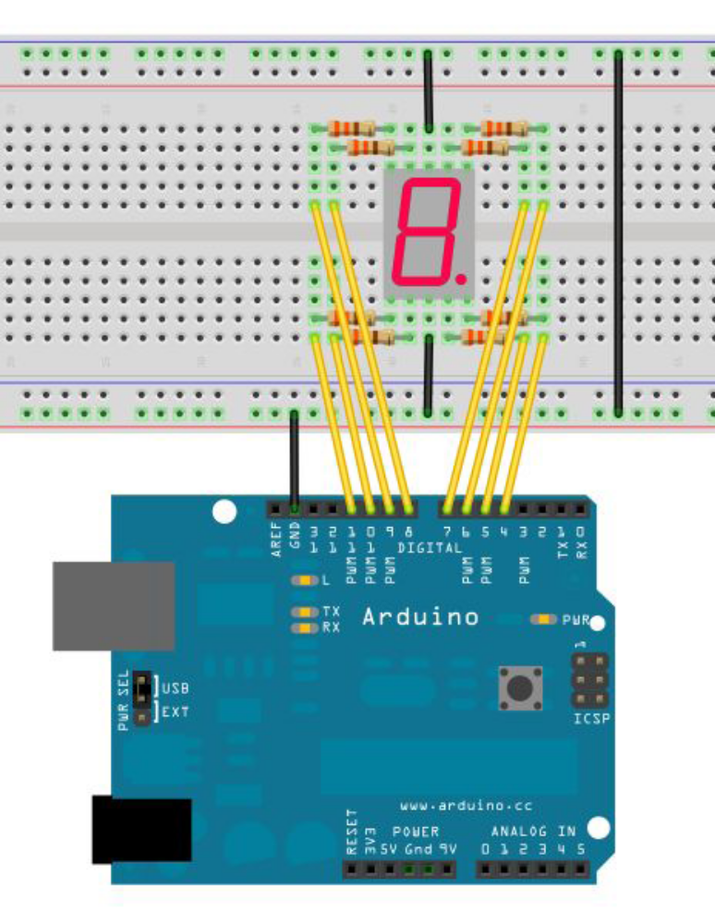
There are 7 segment display the numbers, and 1 segment display the decimal point.Just light up the relevant segments if you want it show numbers.For example, display “1”,connect b and c segment. You can make sub-program for every numbers.Display 1 number in every 2 seconds,make a 1-8 loop in main-program.Delay time determine how long the numbers keep displaying.

- Program for reference
//set digital IO pin for every segment.
int a=7;//set #7 connect a segment.
int b=6;// set #6 connect b segment.
int c=5;// set #5 connect c segment.
int d=11;// set #11 connect d segment.
int e=10;// set #10 connect e segment.
int f=8;// set #8 connect f segment.
int g=9;// set #9 connect g segment.
int dp=4;// set #4 connect dp segment.
void digital_1(void) //display number “1”
{
unsigned char j;
digitalWrite(c,HIGH);//gives #5 pin high level, lighten c segment digitalWrite(b,HIGH);// lighten b segment
for(j=7;j<=11;j++)//turn off the rest segments
digitalWrite(j,LOW);
digitalWrite(dp,LOW);//turn off decimal point DP segment
}
void digital_2(void) // display number “2”

{
unsigned char j;
digitalWrite(b,HIGH);
digitalWrite(a,HIGH);
for(j=9;j<=11;j++)
digitalWrite(j,HIGH);
digitalWrite(dp,LOW);
digitalWrite(c,LOW);
digitalWrite(f,LOW);
}
void digital_3(void) // display number “3”
{
unsigned char j;
digitalWrite(g,HIGH);
digitalWrite(d,HIGH);
for(j=5;j<=7;j++)
digitalWrite(j,HIGH);
digitalWrite(dp,LOW);
digitalWrite(f,LOW);
digitalWrite(e,LOW);
}
void digital_4(void) // display number “4”

{
digitalWrite(c,HIGH);
digitalWrite(b,HIGH);
digitalWrite(f,HIGH);
digitalWrite(g,HIGH);
digitalWrite(dp,LOW);
digitalWrite(a,LOW);
digitalWrite(e,LOW);
digitalWrite(d,LOW);
}
void digital_5(void) // display number “5”
{
unsigned char j;
for(j=7;j<=9;j++)
digitalWrite(j,HIGH);
digitalWrite(c,HIGH);
digitalWrite(d,HIGH);
digitalWrite(dp,LOW);
digitalWrite(b,LOW);
digitalWrite(e,LOW);
}
void digital_6(void) // display number “6”
{
unsigned char j;
for(j=7;j<=11;j++)
digitalWrite(j,HIGH);
digitalWrite(c,HIGH);
digitalWrite(dp,LOW);
digitalWrite(b,LOW);
}
void digital_7(void) // display number “7”
{
unsigned char j;
for(j=5;j<=7;j++)
digitalWrite(j,HIGH);
digitalWrite(dp,LOW);
for(j=8;j<=11;j++)
digitalWrite(j,LOW);
}
void digital_8(void) // display number “8”
{
unsigned char j;
for(j=5;j<=11;j++)
digitalWrite(j,HIGH);
digitalWrite(dp,LOW);
}
void setup()
{
int i;//define variable
for(i=4;i<=11;i++)
pinMode(i,OUTPUT);//set #4-11 pin in output mode
}
void loop()
{
while(1)
{
digital_1();//display number “1”
delay(2000);//delay 2s
digital_2();//display number “2”
delay(1000); //delay 1s
digital_3();//display number “3”
delay(1000); //delay 1s
digital_4();//display number “4”
delay(1000); //delay 1s
digital_5();//display number “5”
delay(1000); //delay 1s
digital_6();//display number “6”
delay(1000); //\delay 1s
digital_7();//display number “7”
delay(1000); //delay 1s
digital_8();//display number “1”
delay(1000); //delay 1s
}
}
After number display sub-program done before setup( ),these definitions can be used in loop().Just put the sub-program name on.

